NG, JAKE JUSTIN Y.

2ECE-D

EXPERIMENT 9

DATA WRANGLING USING PANDAS

PROOF of Testing

PROBLEM #1

1. WORKING CODE

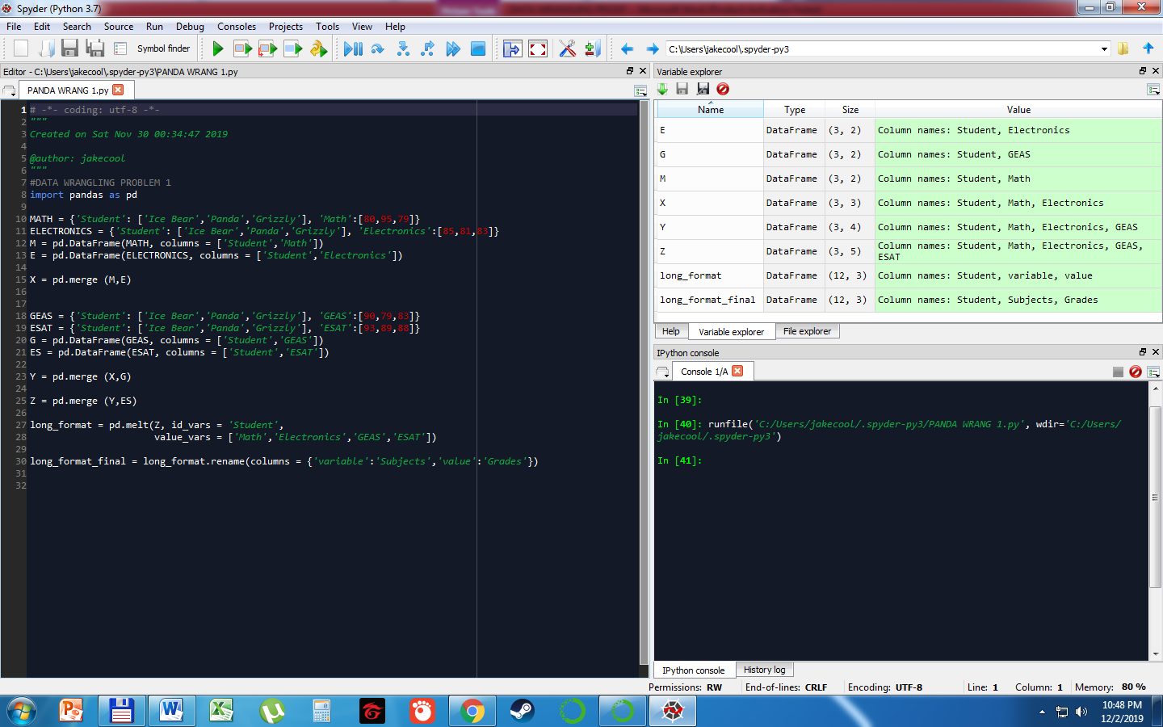

1. MERGED DATAFRAMES

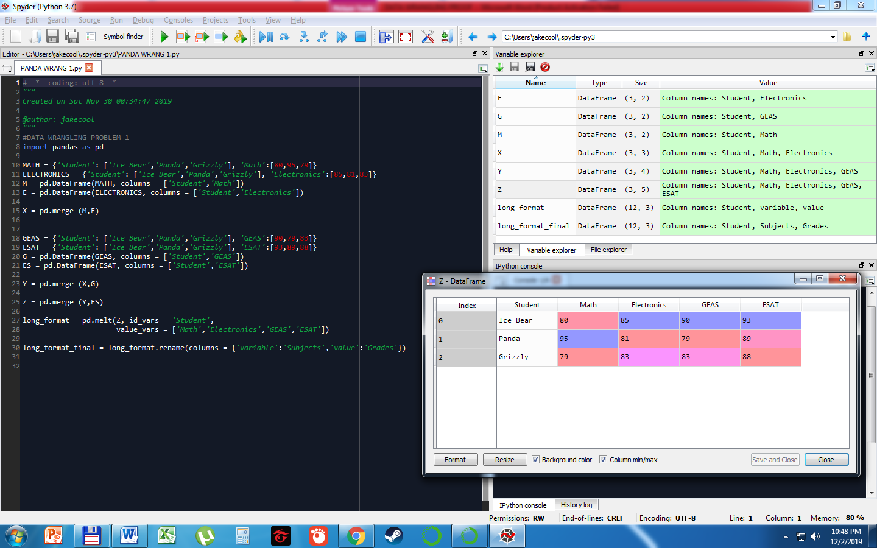

1. LONG FORMAT

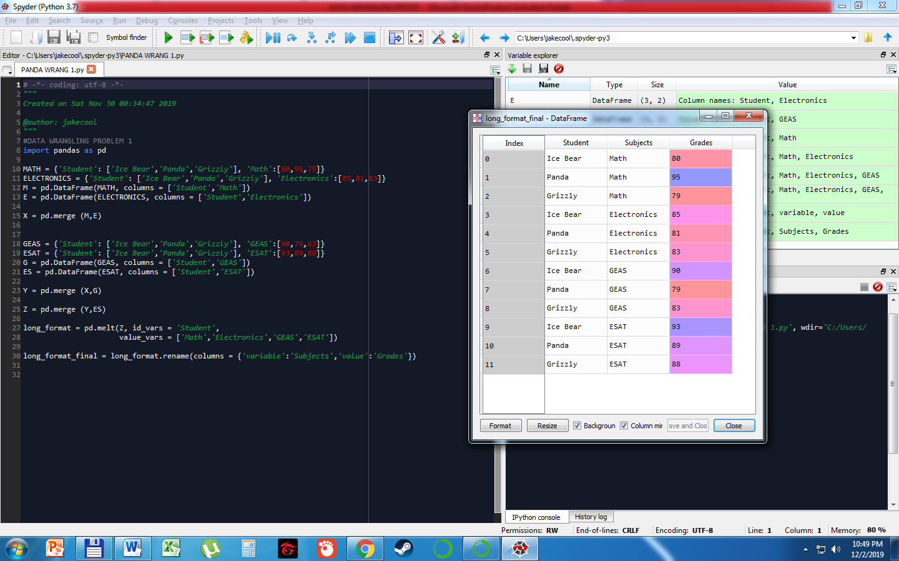

PROBLEM 2

1. WORKING CODE

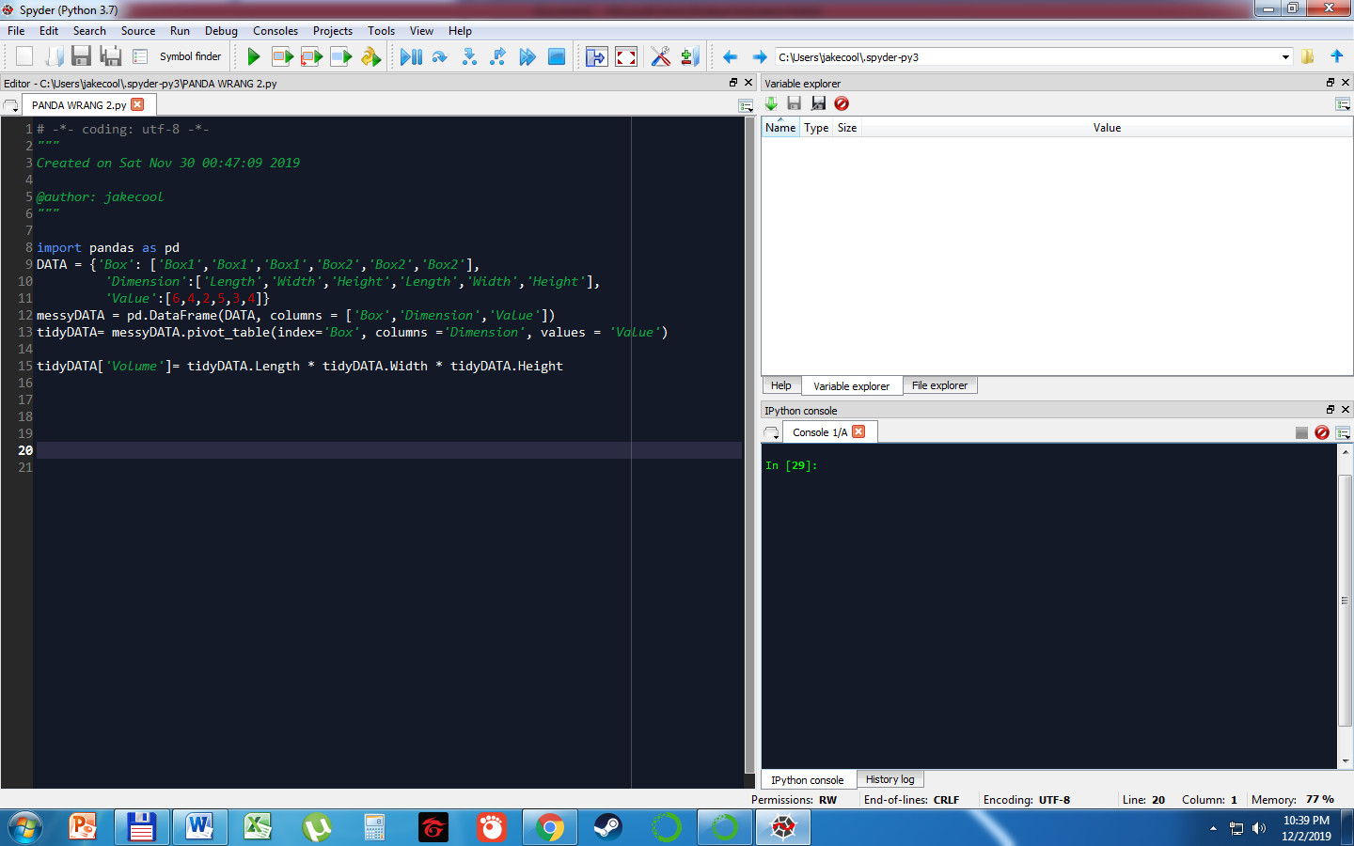

1. TIDY DATA FORMAT

